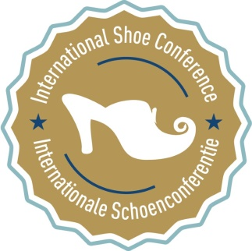
8th International Shoe Conference
7 – 8 November 2018

Enlistment form

Institution - company:

Address:

Country:

E-Mail:

Telephone / mobile phone:

Name(s) of the participant(s):

(Name)…………………………………………………………………………………………will deliver a congress lecture.

Subject of the lecture:

Participation in the day programme of 7 and 8 November 2018 | ..… x €10 / €20 (*)
Participation in the lunch of Thursday noon 8 November 2018 | ….. x €30
Participation in the optional evening programme of Wednesday 7 November 2018. Please indicate:  ( …. ) Supper in Cultuurcafé De Leest with afterwards jazz concert: ‘Homage to Toots Thielemans’  or  ( …. ) Culinary historical walk with city guide: ‘Izegem by night’ | ….. x €35
TOTAL | ∑
(*) Izegem city guides, congress speakers and students pay €10. Regular attendants pay €20.

Please send the completed form to eperondor@izegem, before 31 May 2018. We will deliver the final bill as soon as we have received the form.

